1. Consider the following NAND gate TTL circuit,
  - Let 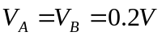 find 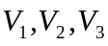 and 
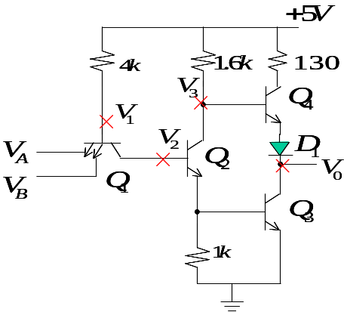
  - Let 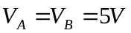 find and
2. The npn transistor in the circuit of Fig. 1.1 has 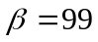. Find the value of 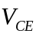.
3. For the circuit in Fig. 1.2 assume that the transistor has very large . Find 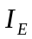 and 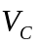 for 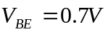.
- A single measurement indicates the emitter voltage of the transistor in the circuit of Fig 1.3 to be 1.0. Under the assumption that 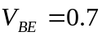, what are 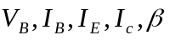 and .

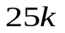

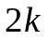
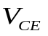




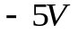

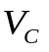
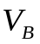
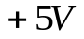


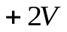

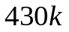
- Measurements on the circuits of Fig.1.4 produce labeled voltages as indicated. Find the value of for the transistor.
Fig.1.1
Fig.1.2
Fig.1.3
Fig.1.4

